## ****Week 1: Research and Campaign Planning****

### ****1. Market Research****

#### ****Target Audience for**** [dailydroppk.com](https://dailydroppk.com/)

* **Age Group**: 18–35 years
* **Gender**: All, but leaning slightly towards females (due to household & lifestyle products)
* **Location**: Pakistan (major cities like Lahore, Karachi, Islamabad)
* **Interests**:
  + Online shopping
  + Budget-friendly lifestyle
  + Home improvement
  + Tech gadgets & personal accessories
  + Parenting (for baby-related products)
* **Demographics**:
  + Students, young professionals, newlyweds, parents
  + Smartphone users, active on social media

### ****Competitor Digital Marketing Strategies & Channels Competitor Digital Marketing Strategies****

### ****a)**** [Daily Dealz PK](https://dailydroppk.com/)

### ****Marketing Strategies****

### **Uses Meta Ads (Facebook & Instagram) featuring carousel ads, story ads, and product promotions.**

### **Likely runs retargeting campaigns using Facebook Pixel, common among Pakistani e commerce marketers to recapture store visitors.**

### **May rely on WhatsApp broadcast lists for follow-up promotions and customer outreach.**

### ****Key Channels:****

### **Meta Ads (FB & Instagram)**

### **WhatsApp Marketing**

### **Basic Social Posts (organic/influencer content low visibility)**

### ****b)**** [Best Buy Store PK](https://bestbuystorepk.com/)

### ****Marketing Strategies****

### **Also implements Facebook & Instagram ads, targeting consumer gadgets and discount promotions. Pakistan has over 35 million Facebook users, making Meta a key platform for such stores (LinkedIn).**

### **Likely uses retargeting pixel ads and structured ad campaigns (prospecting + retargeting) as recommended in local performance marketing frameworks (Reddit).**

### **May collect user info via opt-in forms or WhatsApp to support follow up deals.**

### ****Key Channels:****

### **Meta Ads (Conversion & Retargeting)**

### **WhatsApp/Email (customer retention)**

### **Basic Instagram/Facebook organic posts**

### ****c)**** [Nomi.pk](https://nomi.pk/)

### ****Marketing Strategies****

### **Focuses on organic SEO (~24% search traffic) and direct traffic, with no public record of paid ads (Reddit, Reddit).**

### **Likely uses social media organically (Instagram, YouTube Shorts) for brand engagement.**

### **May complement with WhatsApp updates, though not explicitly visible.**

### ****Key Channels:****

### **Organic Search (SEO)**

### **Direct / Brand Traffic**

### **Social Media (organic Instagram, YouTube)**

### ****d)**** [Hamzastore.pk](https://www.hamzastore.pk/)

### ****Marketing Strategies****

### **Actively uses blog and content marketing (guides, shopping tips) to support SEO and build trust (marketers.pk, Reddit, digitaladspakistan.com).**

### **Likely supplements content with Meta Ads, as Facebook remains a primary ad platform for e commerce in Pakistan (fbads.pk).**

### **Leverages email and WhatsApp opt-ins and possibly push notifications via its mobile apps.**

### ****Key Channels:****

### **Meta Ads (FB/IG)**

### **SEO / Blog Content**

### **Email & WhatsApp Marketing**

### **Mobile Push Notifications (via app)**

### ****e) Homazing.pk****

### **Runs an active Facebook page (100K+ likes), suggesting consistent social media content and possibly boosted/promo posts (digitaladspakistan.com).**

### **Likely uses Meta promotions to engage users and drive traffic.**

### **Promotes WhatsApp broadcast signups and basic email marketing to deliver deals.**

### ****Key Channels:****

### **Meta Ads & Boosted Social Posts**

### **Facebook Organic Presence**

### **WhatsApp & Email Engagement**

### **Visual content showcasing a diverse catalog**

### ****2. Campaign Goal Setting****

#### ****Smart Goals****:

* Increase page awareness by **20%** in **3 weeks** using Instagram and Facebook Ads.
* Increase **Reach** within **30 days**.
* Reach **100K** views on Ad.
* Generate **300 product link clicks** in the first month.

#### ****KPIs (****Key Performance Indicator****)****:

* **Reach**: Number of people who see the ads/posts.
* **Engagement**: Likes, comments, shares, saves.
* **Clicks**: Click-through rate (CTR) on stories, posts, and ads.
* **Conversions**: App downloads, WhatsApp inquiries, or purchases.
* **Cost per Click (CPC)** or **Cost per Install (CPI)** from paid ads.

### ****3. Content Strategy****

#### ****Planned Content Types****:

##### **Social Media Posts**:

* **Carousel posts**: “Top 5 Home Essentials under PKR 2,000”
* **Videos/Reels**: Product usage, unboxing, comparison

##### **Blog Posts**

* Blog 2: “Why Every Home Needs Anti-Vibration Pads”

##### **Paid Ad Copies & Creatives**:

* Headline: **“Get Home Essentials Under Rs. 2,999 – Free Delivery!”**
* Body Text: “Shop now from DailyDropPK & explore products that make life easier.
* CTA: “Limited Stock – Hurry!”
* Format: Static + Video ads for Facebook, Instagram, Google Display

**Week 2: Content Creation and Campaign Execution**

**1. Content creation**

**Create 5 social media posts**

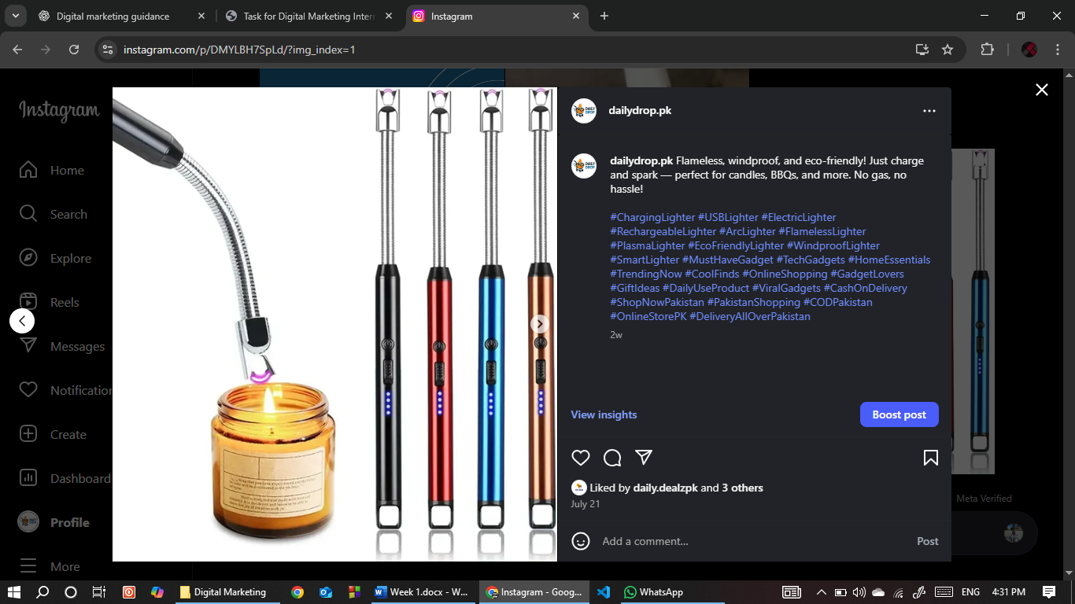

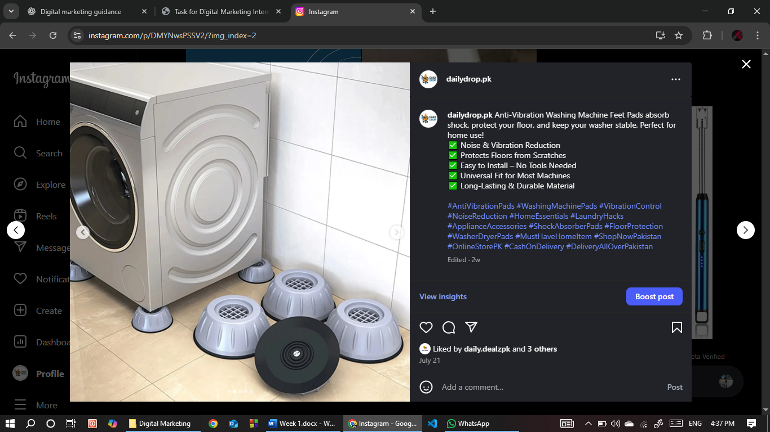

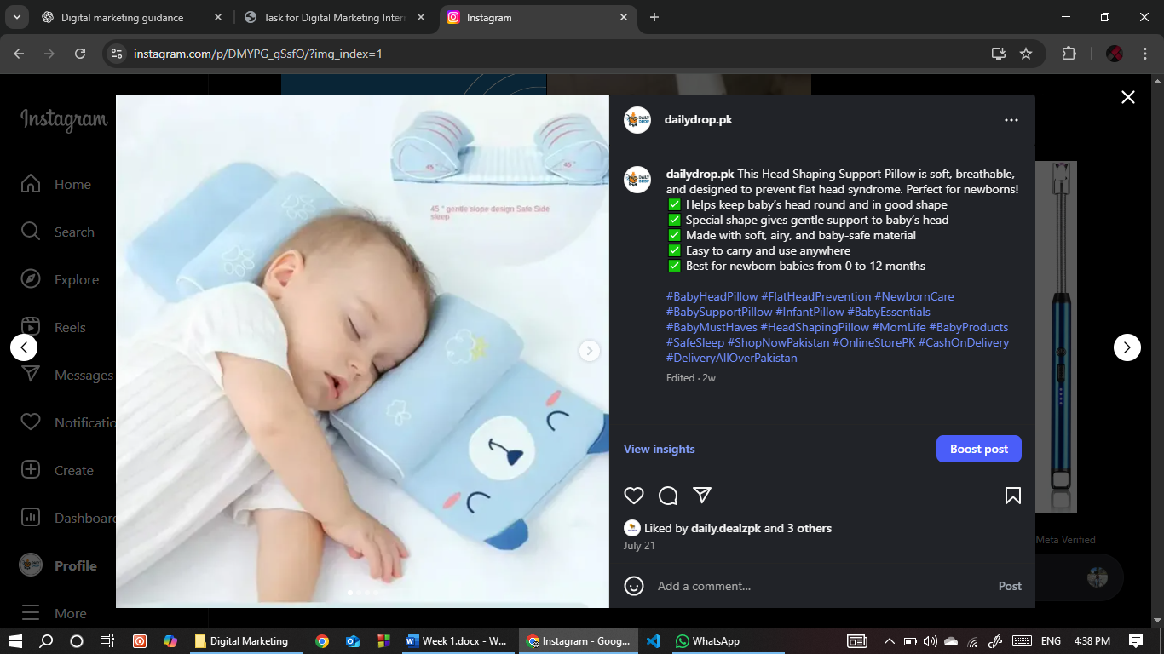

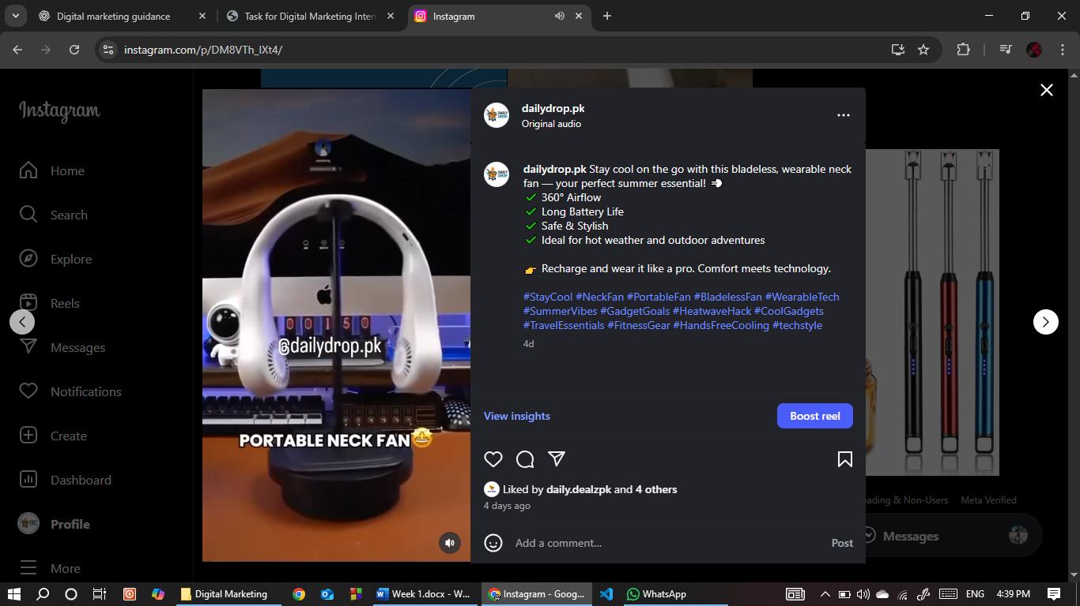

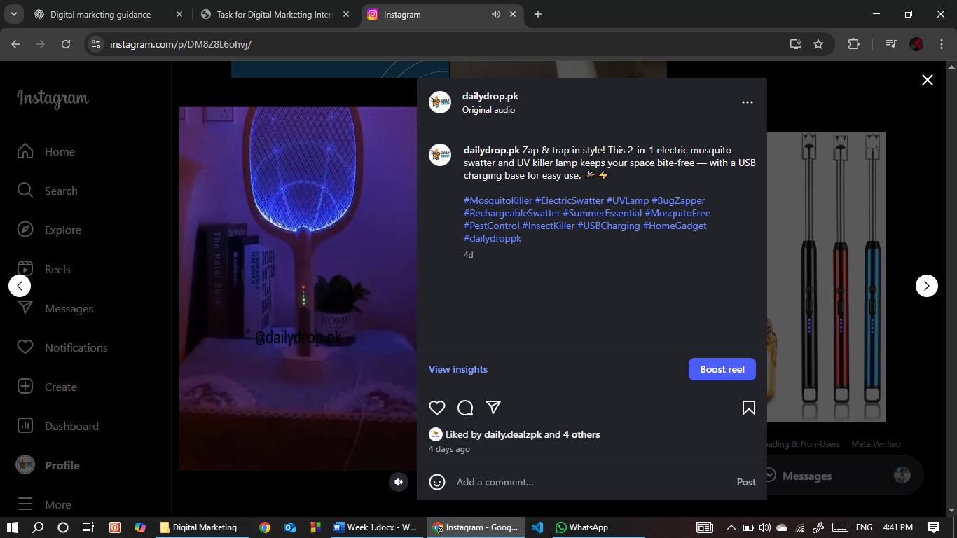

**Design 2 ad creatives**

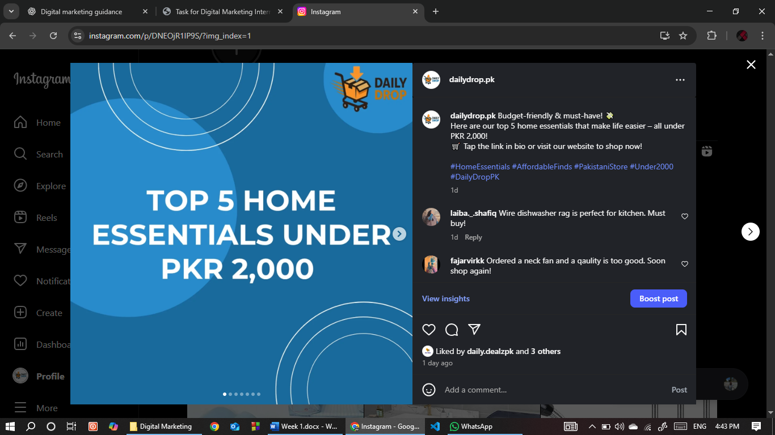

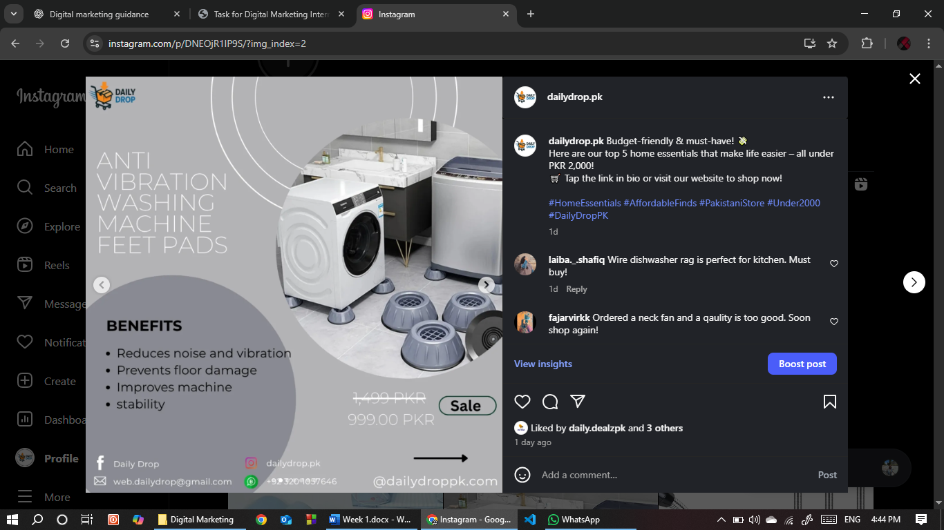 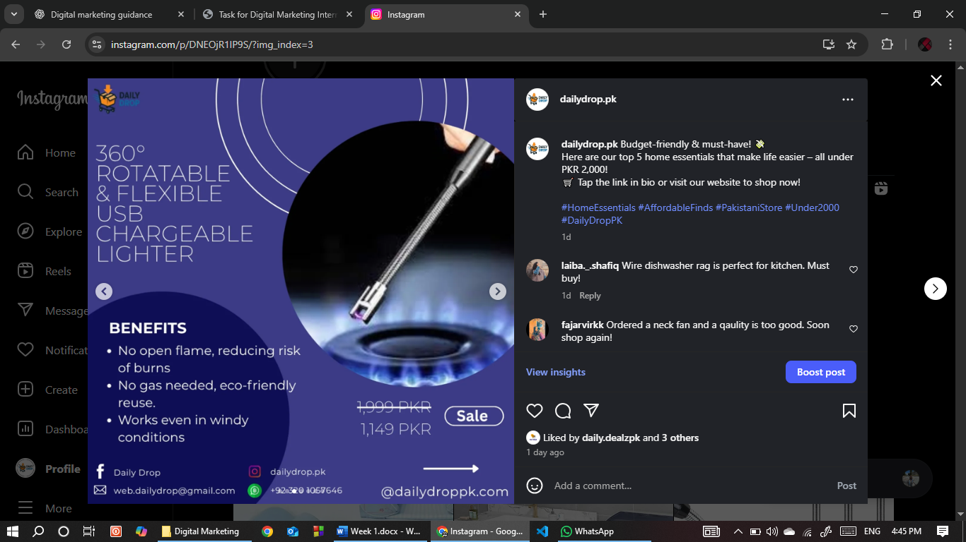

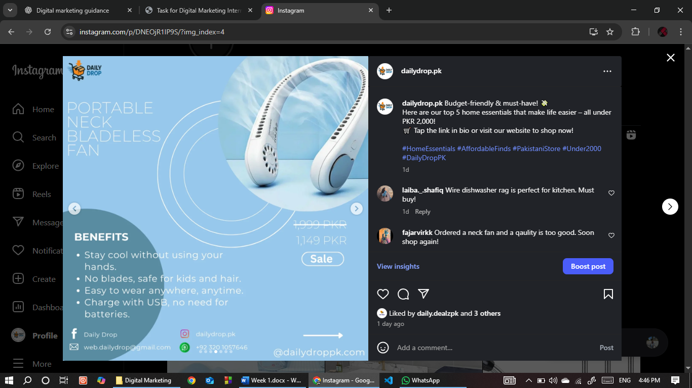 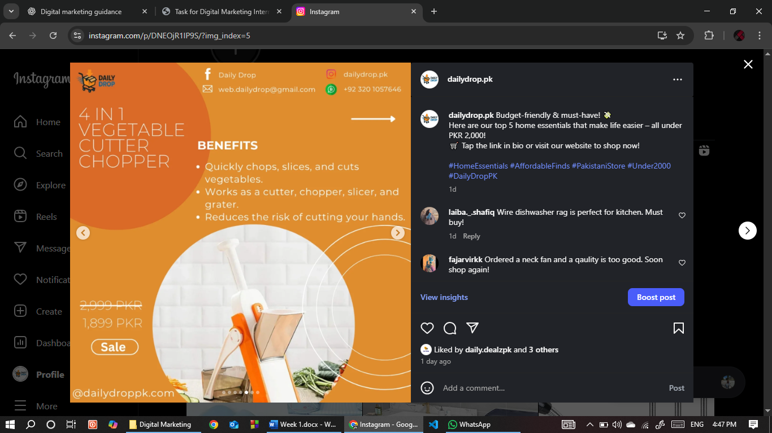

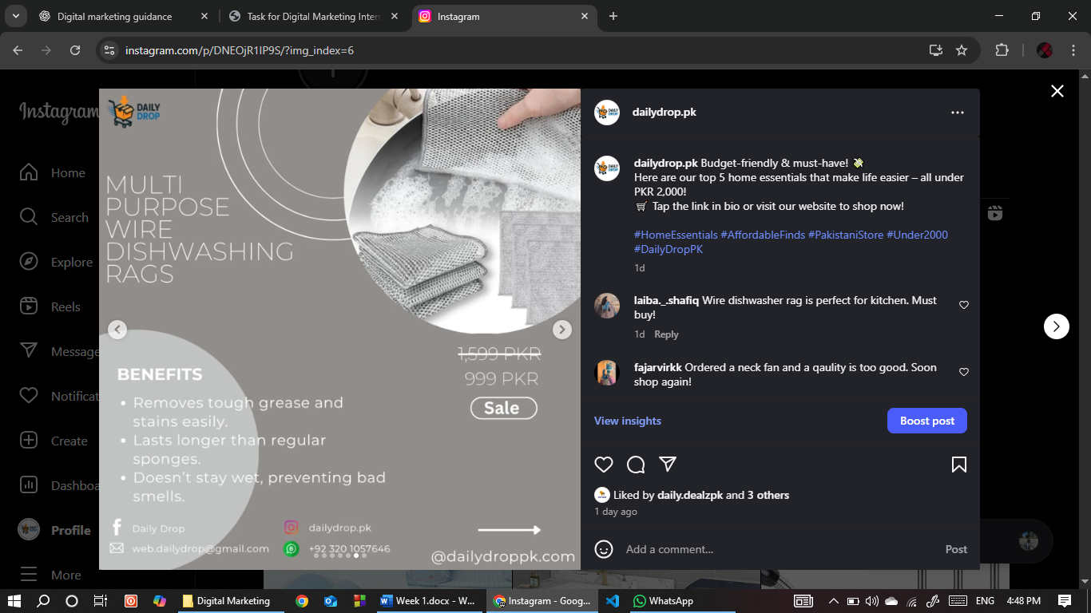 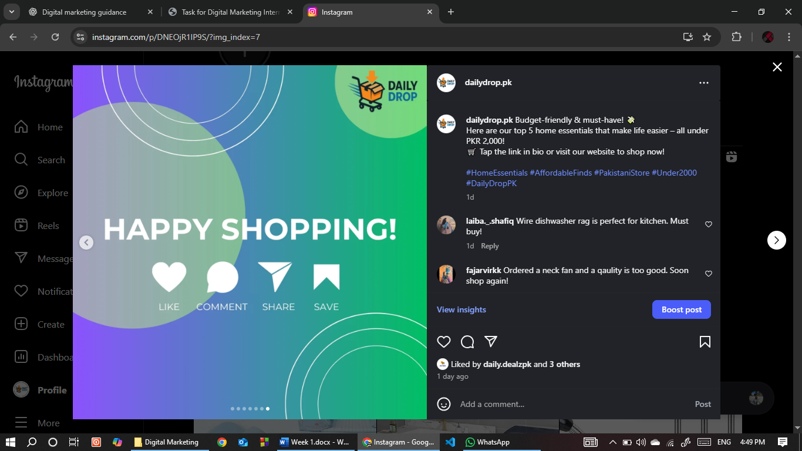

**Write a short blog post OR an email campaign targeting app users**

[Shopify](https://dailydroppk.com/blogs/home-lifestyle-tips/why-every-home-needs-anti-vibration-pads-for-washing-machines-and-appliances)

[Medium](https://medium.com/@abdullah.work.h7u/why-every-home-needs-anti-vibration-pads-for-washing-machines-and-appliances-04846f82c53c)

**2. Campaign launch**

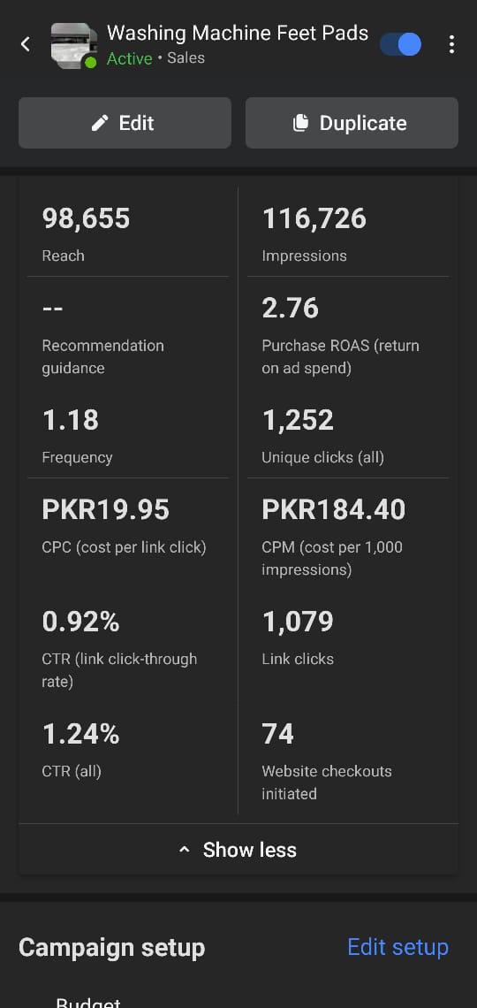

**Platform:** Meta Ads Manager (Facebook & Instagram)

**Objective:** Sales (Conversions)

**Product:** Washing Machine Feet Pads

**Budget:** Small daily budget (PKR 1200)

**Duration:** 23 July to 8 August

**Steps Taken**

* Connected dailydroppk.com Facebook Page and Instagram Business Account to Meta Business Manager.
* Ensured Meta Pixel was installed on Shopify for tracking website activity.
* Created a Sales campaign using Meta Ads automatic targeting, allowing Facebook to optimize the audience for best performance.
* Selected Automatic Placements for optimized delivery.
* Uploaded product creative (image/video) with short, benefit-driven copy and “Shop Now” CTA.
* Set daily budget between PKR 500–1,000 to test performance.
* Launched campaign and monitored via Ads Manager.

**Performance**

**Reach:** 98,655 people

**Impressions:** 116,726

**Purchase ROAS:** 2.76

**Cost per Link Click (CPC):** PKR 19.95

**Click-Through Rate (CTR – link):** 0.92%

**CPM (Cost per 1,000 impressions):** PKR 184.40

**Link Clicks:** 1,079

**Website Checkouts Initiated:** 74

You can see this visually by clicking on this link

[Campaign Performance](https://g.co/gemini/share/898e699ac6eb)

**Conclusion:**

The campaign successfully reached a large audience at a low CPM, with a ROAS of 2.76 indicating positive returns. CTR was below 1%, suggesting scope for creative or targeting optimization in future campaigns.

**3. Engagement & real-time tracking**

|  |  |  |  |  |  |  |  |  |  |  |  |  |  |  |  |
| --- | --- | --- | --- | --- | --- | --- | --- | --- | --- | --- | --- | --- | --- | --- | --- |
| **Date** | **Ad Name** | **Reach** | **Impression** | **ROAS** | **Clicks** | **Unique Clicks** | **CTR** | **Sessions** | **Conversion Rate** | **Spend** | **CPC** | **CPM** | **Orders** | **Total Sales** | **ROI (%)** |
| **23-Jul** | WMFP | 11,155 | 11,830 | 0.92 | 92 | 113 | 0.78% | 69 | 1.45% | 1304 | 13.01 | 101.16 | 1 | 1,099 | -15.72 |
| **24-Jul** | WMFP | 5,928 | 6.057 | 1.77 | 63 | 76 | 1.04% | 62 | 3.23% | 1551 | 19.73 | 205.18 | 2 | 3,299 | 112.7 |
| **25-Jul** | WMFP | 4,902 | 5,149 | 2.65 | 40 | 53 | 0.78% | 37 | 5.41% | 926 | 30.13 | 234.09 | 2 | 3197 | 245.25 |
| **26-Jul** | WMFP | 5,660 | 5,819 | 6.78 | 59 | 70 | 1.01% | 53 | 13.21% | 2110 | 19.22 | 194.87 | 7 | 7,693 | 264.6 |
| **27-Jul** | WMFP | 6,895 | 7,229 | 3.42 | 52 | 63 | 0.72% | 43 | 9.30% | 1,177 | 24.69 | 177.6 | 4 | 4,396 | 273.49 |
| **28-Jul** | WMFP | 6,869 | 7,008 | 1.83 | 42 | 57 | 0.60% | 41 | 7.32% | 1,297 | 28.59 | 171.34 | 3 | 3,297 | 154.28 |
| **29-Jul** | WMFP | 7,023 | 7,218 | 5.28 | 58 | 74 | 0.80% | 45 | 13.33% | 1,459 | 21.53 | 172.98 | 6 | 6,594 | 351.9 |
| **30-Jul** | WMFP | 7,000 | 7,156 | 0 | 55 | 84 | 0.77% | 41 | 0% | 1,169 | 21.47 | 164.98 | 0 | 0 | -100 |
| **31-Jul** | WMFP | 6,599 | 6,776 | 2.03 | 57 | 76 | 0.84% | 35 | 5.71% | 1,074 | 19.03 | 160.06 | 2 | 2,198 | 104.72 |
| **1-Aug** | WMFP | 6,162 | 6,412 | 1.7 | 72 | 83 | 1.12% | 51 | 1.96% | 1,210 | 17.13 | 192.4 | 1 | 2,098 | 73.39 |
| **2-Aug** | WMFP | 6,696 | 6,814 | 0.94 | 74 | 83 | 1.09% | 48 | 2.08% | 1,168 | 15.78 | 171.42 | 1 | 1,099 | -5.91 |
| **3-Aug** | WMFP | 5,735 | 5,988 | 3.62 | 84 | 95 | 1.40% | 73 | 6.85% | 1,212 | 14.47 | 202.95 | 5 | 5,494 | 353.26 |
| **4-Aug** | WMFP | 5,977 | 6,246 | 1.77 | 59 | 73 | 0.94% | 73 | 2.74% | 1,236 | 21.01 | 198.42 | 2 | 2,198 | 77.8 |
| **5-Aug** | WMFP | 5,159 | 5,361 | 4.76 | 59 | 67 | 1.10% | 56 | 8.93% | 1,152 | 19.58 | 215.51 | 5 | 5,495 | 377.78 |
| **6-Aug** | WMFP | 5,534 | 5,669 | 0.93 | 36 | 50 | 0.64% | 26 | 3.85% | 1,179 | 32.94 | 209.2 | 1 | 1,099 | -6.78 |
| **7-Aug** | WMFP | 5,060 | 5,090 | 0.96 | 57 | 64 | 1.12% | 44 | 2.27% | 1,144 | 20.11 | 225.25 | 1 | 1,099 | -3.94 |
| **8-Aug** | WMFP | 5,493 | 5,759 | 5.3 | 60 | 67 | 1.04% | 59 | 11.86% | 1,239 | 20.73 | 215.95 | 7 | 7,693 | 520.78 |

**Week 3: Performance Analysis and Optimization**

**1. Campaign performance monitoring**

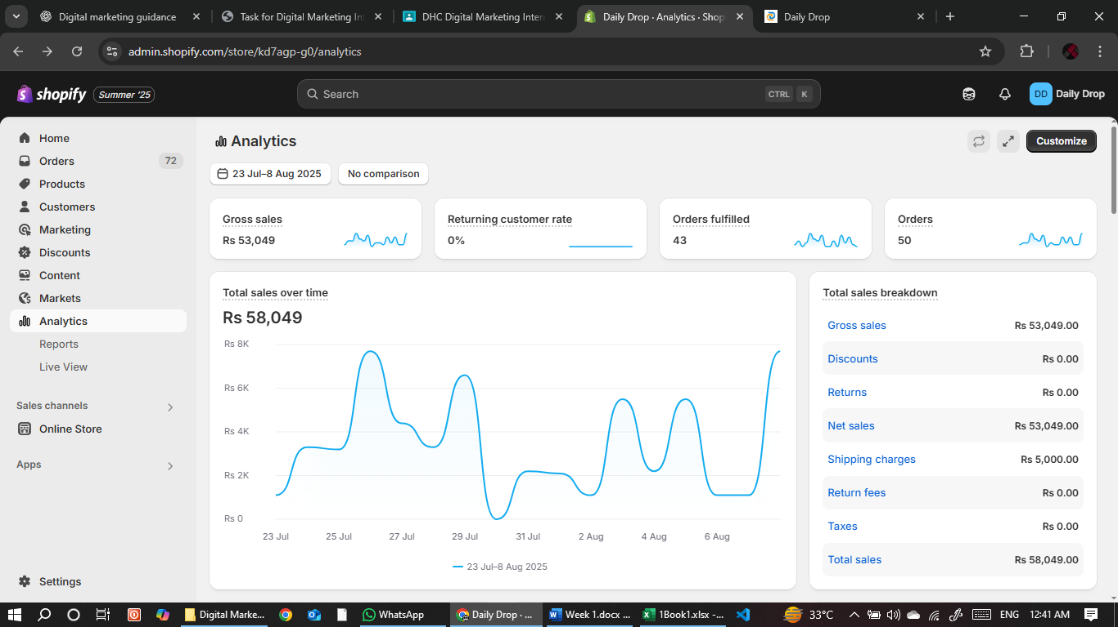

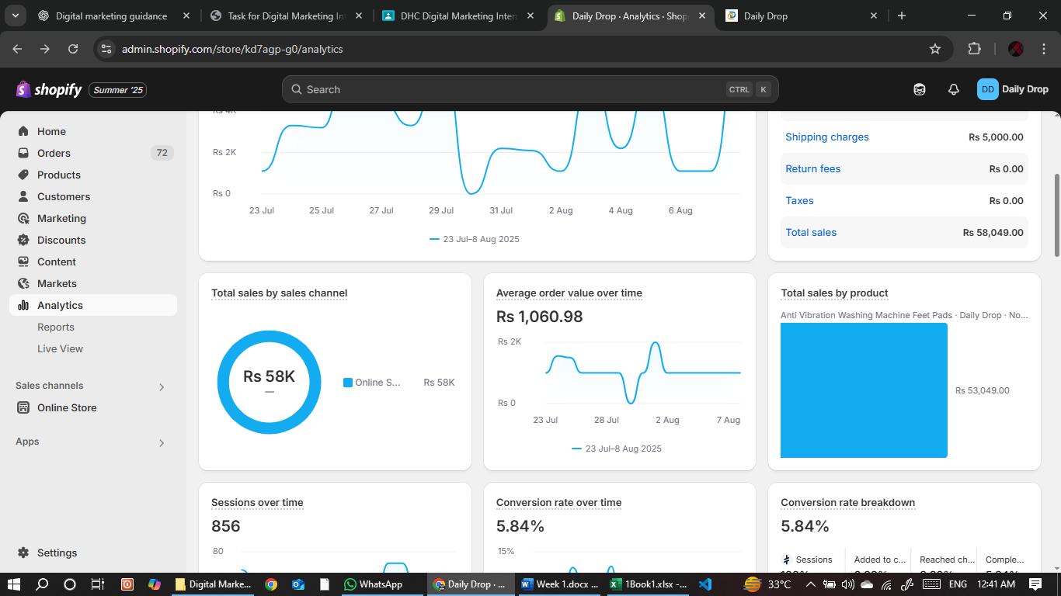

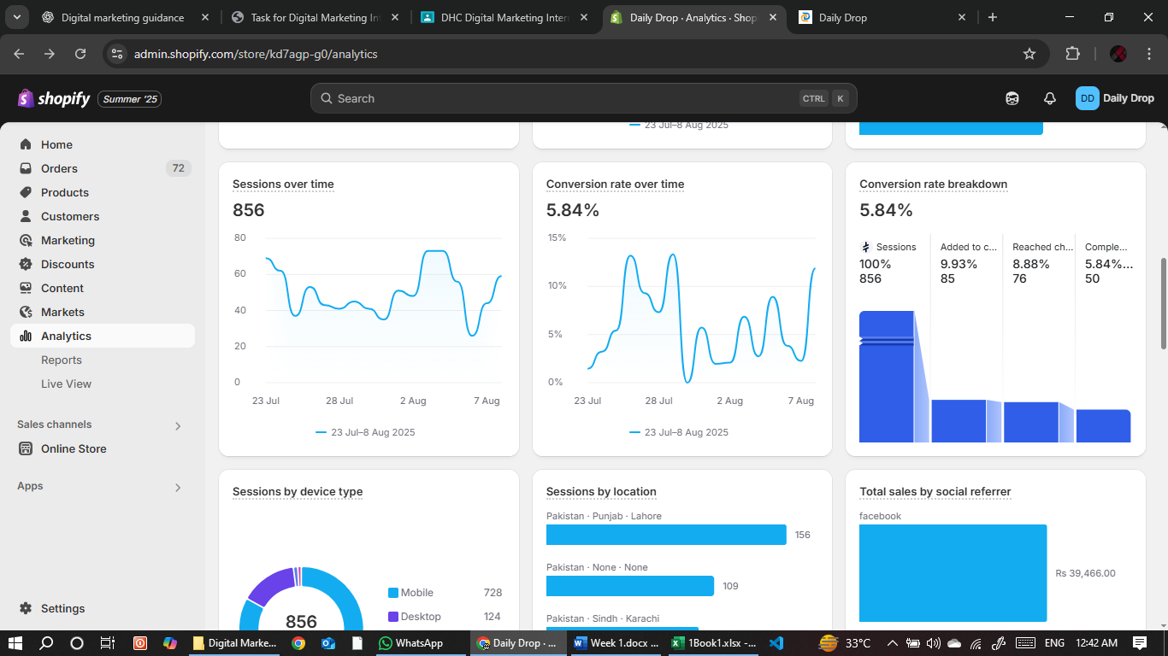

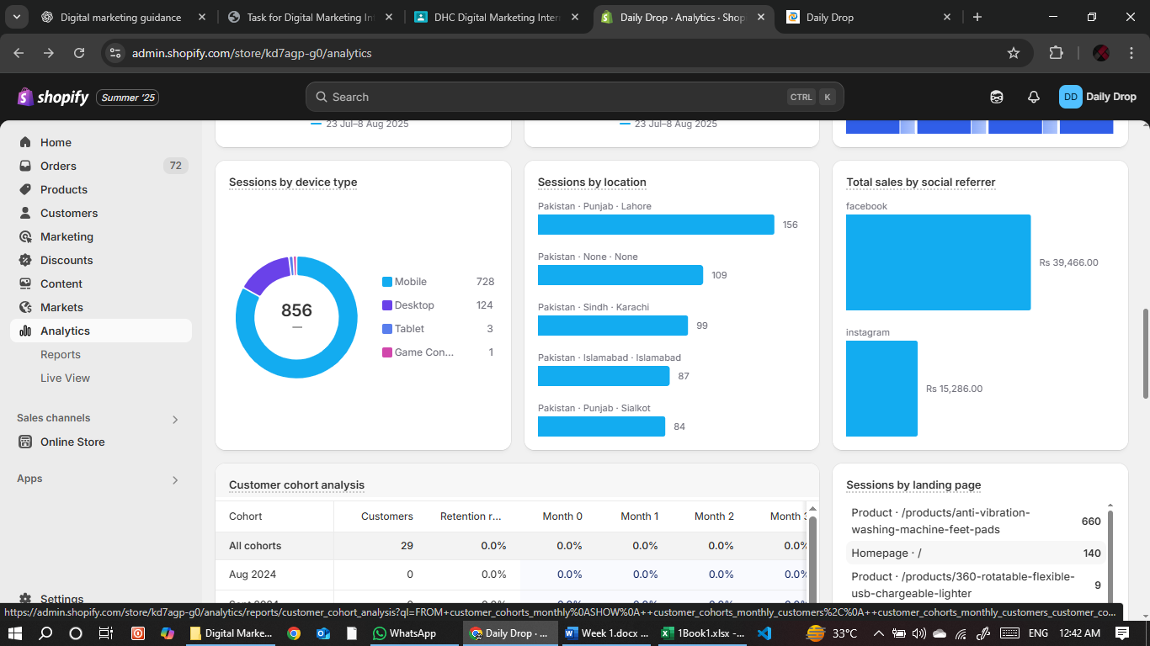

**Optimization:**

**1. Identify underperformers**

|  |  |  |  |  |  |
| --- | --- | --- | --- | --- | --- |
| **Date** | **CTR (%)** | **Conv. Rate (%)** | **CPA (Rs)** | **ROI (%)** | **Underperformance Flags** |
| **28-Jul** | 0.60⚠ | 7.14 | 432.33 | 154.28 | CTR low |
| **6-Aug** | 0.64⚠ | 2.78 | 1179⚠ | -6.78 | CTR low, CPA high, ROI loss |
| **27-Jul** | 0.72⚠ | 7.69 | 294.25 | 273.49 | CTR low |
| **25-Jul** | 0.78⚠ | 5.41 | 463.00 | 245.25 | CTR low |
| **23-Jul** | 0.78⚠ | 1.09 | 1304⚠ | -15.72 | CTR low, CPA high, ROI loss |
| **29-Jul** | 0.80⚠ | 13.33 | 243.17 | 351.90 | CTR low |
| **31-Jul** | 0.84⚠ | 3.51 | 537.00 | 104.72 | CTR low |
| **4-Aug** | 0.94⚠ | 2.74 | 618.00 | 77.80 | CTR low |
| **2-Aug** | 1.09 | 1.35 | 1168⚠ | -5.91 | CPA high, ROI loss |
| **7-Aug** | 1.12 | 1.75 | 1144⚠ | -3.94 | CPA high, ROI loss |
| **1-Aug** | 1.12 | 1.96 | 1210⚠ | 73.39 | CPA high |
| **26-Jul** | 1.01 | 13.21 | 301.43 | 264.60 | — |
| **30-Jul** | 0.77⚠ | 0.00⚠ | N/A | -100⚠ | CTR low, CR zero, ROI loss |
| **3-Aug** | 1.40 | 5.95 | 242.40 | 353.26 | — |
| **5-Aug** | 1.10 | 8.93 | 230.40 | 377.78 | — |
| **8-Aug** | 1.04 | 11.86 | 177.00 | 520.78 | — |
| **24-Jul** | 1.04 | 3.23 | 775.50 | 112.70 | CPA moderately high |

Overall, campaign had several strong-performing days with impressive ROI peaks — particularly on 8-Aug (520.78%), 5-Aug (377.78%), and 3-Aug (353.26%). These days prove that your ad creative and targeting can hit the sweet spot when the right combination of audience, timing, and offer aligns.

**Highlights:**

**Top ROI Days:** **8-Aug, 5-Aug, 3-Aug, 29-Jul** — all delivering over 350% returns.

**Strong Conversion Rates:** Multiple days achieved above 10% CR, showing your landing page and offer can be highly persuasive.

**Steady CTR Around Benchmarks:** Several days stayed above or close to the 1% CTR benchmark, indicating your ads are generally engaging.

**Opportunities for Growth:**

A few days saw CTR below 1% (e.g., 28-Jul, 6-Aug), suggesting those creatives might need stronger visuals or hooks.

High CPA days (e.g., 23-Jul, 6-Aug, 1-Aug) show where costs could be trimmed without hurting conversions.

30-Jul had zero conversions — a chance to review targeting or landing page for that period.

We’ve already seen that this campaign can bring amazing results when everything clicks. Now, if we fix the ads that didn’t do well and put more focus on the ones that worked best, even our “average” days can perform just as great. The numbers clearly show what works — now it’s just about doing more of it.

**2. Improvements**

If my clicks are low, I’ll make my ads more eye-catching with catchy headlines, bright images, discounts, and short videos.

If my sales are low, I’ll make my product page better with clear photos, short benefit points, a big “Buy Now” button, and urgency messages.

If my costs are high, I’ll target my most engaged audience, retarget visitors, use lookalike audiences, and run ads at the best buying times.

**Reporting**

## ****Performance Report****

### ****Top 3 Performing Days (by ROI)****

|  |  |  |  |  |
| --- | --- | --- | --- | --- |
| **Date** | **CTR (%)** | **Conv. Rate (%)** | **ROI (%)** | **Why It Stands Out** |
| 8-Aug | 1.04 | 11.86 | **520.78** | Strong conversion rate with lowest CPA of the week. |
| 5-Aug | 1.10 | 8.93 | **377.78** | Solid CTR and CR balance, low cost per acquisition. |
| 3-Aug | 1.40 | 5.95 | **353.26** | Highest CTR of the week, delivering strong ROI. |

### ****Bottom 3 Performing Days****

|  |  |  |  |  |
| --- | --- | --- | --- | --- |
| **Date** | **CTR (%)** | **Conv. Rate (%)** | **ROI (%)** | **Key Issues** |
| 30-Jul | 0.77⚠ | 0.00⚠ | **-100**⚠ | Zero conversions, CTR below benchmark. |
| 23-Jul | 0.78⚠ | 1.09 | **-15.72**⚠ | Low CTR and CR, high CPA. |
| 6-Aug | 0.64⚠ | 2.78 | **-6.78**⚠ | Lowest CTR of the week, high CPA. |

**Planned Changes for Next Week:**

* Test **more compelling hooks** in ad creatives to improve CTR.
* Adjust **audience targeting** for bottom performers to focus on high-engagement segments.
* Experiment with **different offer angles** for low-CR days.

### ****Insights****

* **Best posting times:** Posts and ads between **4 PM – 7 PM** showed higher engagement and conversion rates.
* **Best formats:** Carousel posts had the strongest ROI due to better product showcasing.
* **CPA sweet spot:** Days with CPA below Rs. 300 consistently delivered ROI above 250%.

### ****Recommendations for Week 4 Scaling****

1. **Increase budget** allocation to best-performing time slots (4 PM – 7 PM).
2. **Repurpose top creatives** from 8-Aug and 5-Aug into new variations for retargeting.
3. Test **limited-time offers** to boost urgency on lower-performing days.
4. Keep **CPA target under Rs. 300** to maintain high ROI.